**The optical alignment and real-time feedback control for FIR laser on High-scattering system**

**Abstract**

Far-infrared (FIR) lasers are essential tools for high-resolution diagnostics in plasma physics, particularly for studying electron dynamics in fusion devices. This study introduces a systematic method for enhancing FIR laser beam quality through optimized mirror alignment, precise cavity length tuning, and real-time feedback control. A high-power CO₂ laser, aligned to the waveguide axis using a HeNe reference laser, serves as the pump source. The sensitivity of FIR beam intensity to pump gas pressure and thermal expansion is investigated, revealing that even a 1 μm cavity expansion can significantly disrupt beam stability. To counteract this, a feedback control system—comprising a stepper motor and a power-monitoring algorithm—dynamically adjusts the cavity length, stabilizing output power at ~30 mW. Additionally, high formic acid gas pressure (>190 mTorr) within the cavity ensures reliable operation. These improvements enable more stable and precise FIR laser diagnostics for studying electron turbulence in tokamak plasmas, advancing research in fusion reactor physics.

**Introduction**

Electron turbulence represents an essential research focus in tokamak physics due to its dominant role in plasma energy transport. Unlike ion-scale turbulence, electron-scale fluctuations drive particularly severe heat losses that directly compromise fusion efficiency. Understanding and controlling these electron dynamics is therefore essential for achieving viable tokamak operation. For diagnosing these small-scale fluctuations, high-k scattering systems employ a Bragg scattering technique. The method launches high-k probe waves into the plasma and analyzes scattered signals at specific angles. The system detects density fluctuations when their wavenumber k satisfies the Bragg condition: k = 2kᵢsin(θₛ/2), as shown in Figure 1 ,where kᵢ is the incident wavenumber, k = 2/d is the plasma turbulence wavenumber and θₛ is the scattering angle between the incident and received beam paths. This approach enables precise measurement of electron-scale turbulence characteristics.

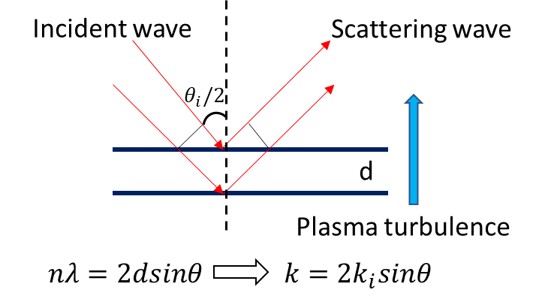

Figure 1. Bragg condition in plasma turbulence. Here n = 1 and k = 2/d.

A 693 GHz poloidal high-k𝜃 scattering system, jointly developed by the Princeton Plasma Physics Laboratory (PPPL) and the University of California at Davis Millimeter Wave Plasma Diagnostics Group (UC Davis MMWPDG), is designed to study predicted electron temperature gradient (ETG) modes with improved wavenumber range and resolution. The system employs an optically pumped far-infrared (FIR) laser using formic acid (HCOOH) vapor as the gain medium, pumped by a 150 W CO₂ laser operating at the 9R20 line (9.27 μm), which generates the 693 GHz FIR signal through rotational transitions. The output beam is coupled into a waveguide and transmitted to launch optics, where adjustable mirrors enable precise beam steering for different measurement configurations. Critical to performance is maintaining a Gaussian beam profile for optimal waveguide coupling, which depends heavily on the alignment of the FIR cavity optics—including perforated copper mirrors, mesh grids, and dielectric wafers. Even minor mirror misalignments (as small as 0.1°) can significantly degrade beam quality, yet detailed alignment methodologies are rarely discussed in the literature. This work addresses this gap by presenting a systematic approach to mirror adjustment, emphasizing key techniques for stabilizing beam output and optimizing profile quality.

The FIR laser cavity utilizes specialized optics, which including centrally perforated copper mirrors, mesh grids, and dielectric wafers, to sustain wave resonance. Maintaining a high-quality beam profile demands exceptional alignment precision, as angular deviations as small as 0.1° can drastically distort the output beam. Despite this critical sensitivity, practical guidance for mirror adjustment and quantitative beam characterization remains scarce in existing literature. This work bridges that gap by introducing a repeatable alignment methodology and identifying the dominant factors governing beam stability and profile optimization in FIR systems.

This paper focuses on the alignment of the pump gas laser system, stability analysis, and power control. Section 2 reviews the combined system of the CO₂ laser and the FIR laser. Section 3 discusses the optical alignment of both laser systems. In Section 4, a brief discussion of the power distribution within the cavity is provided. Section 5 presents an automatic cavity adjustment method, along with the determination of the optimal gas pressure to suppress instability caused by cavity shifts. Section 6 presents the final results of the laser beam profile after alignment. A summary is provided in Section 7.

**The Overview of the Laser System**

Make a short paragraph about the laser systems (CO2 and FIR), including system diagram, photos, application, and more.

The CO2 laser system and FIR laser system are working as a whole laser system to produce coherent laser at 693 GHz. The CO₂ laser serves as the pump source, providing high-power, linearly polarized radiation at a wavelength of 9.27 μm. This radiation is directed into the FIR laser cavity, which contains formic acid gas as the gain medium. The FIR laser operates based on molecular rotational transitions, generating radiation in the submillimeter range (e.g., around 432 μm), corresponding to the far-infrared region. A schematic diagram of the system, as shown in Fig. 1, illustrates the optical path and key components

The CO₂ laser schematic shown in Fig. 1 features two independent waveguide cavities, each powered by a dedicated high-voltage supply (-15 kV cathode, 0 V anode) that initiates gas breakdown in the CO₂-N₂-He mixture (6:18:76 ratio). This discharge sustains a 40 mA plasma current that excites CO₂ molecules, producing infrared radiation through quantum cascade transitions. The system employs Brewster windows to enforce P-polarization (100% transmission) while suppressing S-polarization through reflection and absorption. Wavelength selection is achieved via a tunable diffraction grating, which together with the output coupler's ZnSe mirror (60% reflectivity at 10 μm) forms the complete laser cavity. Resonant feedback between these components stimulates continuous laser action, with maximum output occurring when the cavity length satisfies the standing wave condition. Fine adjustment of this critical length (up to 15 μm precision) is accomplished through a piezoelectric crystal stack in the output coupler, controlled by 1500 V DC bias (max.).

Please add 2- 3 sentences between last paragraph and following one. The optical and control systems of the PL-6 CO₂ laser are shown in Figures 2 and 3. The wavelength selection assembly (Fig. 2) consists of a Brewster window for polarization control and a tunable diffraction grating, where precise wavelength adjustment is achieved through a mechanical knob with indexed counter readout. The main control panel (Fig. 3) integrates all critical subsystems: (1) laser cavity optimization via piezoelectric length adjustment, (2) gas handling with flow control and vacuum systems (Figs. 3a-b), including real-time pressure monitoring, and (3) thermal management through liquid cooling ports. Power is supplied by dual high-voltage sources (15 kV, 40 mA each), enabling stable operation of the complete laser system.

The schematic of the FIR system is shown in Fig. 4. The system consists of a rear mirror, a dielectric waveguide tube, a front mirror, and a metallic mesh. The rear mirror is a copper mirror coated with gold, featuring a central hole to allow the CO₂ laser to pass through. The front mirror is a dielectric-coated silicon wafer, designed to provide high FIR transmission (98%) and high CO₂ laser reflection (99%). The metallic mesh has a density of 300 lines per inch (lpi), with 20% transmission and 80% reflection for FIR radiation at a 432 μm wavelength.

The front mirror and metallic mesh are mounted on a stage that can be adjusted along the waveguide axis, driven by a stepper motor. The CO₂ laser oscillates between the front and rear mirrors, while the FIR laser oscillates between the metallic mesh and the rear mirror. By adjusting the cavity length between the metallic mesh and the rear mirror, the output power can be optimized to its maximum value. The output window of the FIR laser system is made of HDPE with plano surfaces, as a concave surface would distort the beam profile.

As illustrated in Fig. 5, the combined laser system comprises a CO₂ laser, a FIR laser system with a focusing lens, and a reflector mirror to facilitate coupling the CO₂ laser beam into the FIR cavity. The CO₂ laser beam has an initial diameter of approximately 11 mm at the output coupler, while the FIR input window is only 10 mm in diameter. To ensure efficient coupling, a focusing lens with a focal length of about 1 m is used to concentrate the CO₂ beam. The focused beam converges to a spot diameter of roughly 3 mm, positioned between the FIR input window and the rear mirror (Fig. 4a). This configuration ensures the CO₂ laser fully fills the FIR waveguide, stimulating the formic acid gas to generate continuous FIR laser emission. The FIR laser’s beam profile and output intensity are highly sensitive to optical alignment and system configuration. Even a slight misalignment of 0.1° can significantly distort the beam profile. Therefore, meticulous alignment is essential to achieving optimal beam quality and maximizing output power.

